Jessica: Embed link within Realizeit please

Direct Object Pronouns
 | singular | plural
1st person | me me | nos us
2nd person | te you | Os you plural informal
3rd person | lo, la him/her/you formal | los, las them/you plural formal

Description
A direct object is a noun following the verb that answers the questions what? or whom? Remember a pronoun replaces a noun, and in this case the noun is a direct object. Verbs that have a direct object are called transitive verbs.
Direct object pronouns in Spanish agree in number and gender with the nouns they replace. In the following example, hijos is a masculine, plural noun so the masculine plural direct object pronoun los is used to replace it in the second sentence.
Son muy buenos hijos. No los cambiaría.They are good kids. I wouldn’t change them.

Placement
There are two places where direct object pronouns can be placed.
- Before a conjugated verb.
- Attached to the end of the verb, ONLY IF the verb is not conjugated, such as infinitives or gerunds or if the verb is an affirmative informal command.
In the following example, both direct objects te and lo are placed before the conjugated verbs: cambia and tomas.
Pero te cambia mucho en la perspectiva ya cuando estudias más grande porque ya el estudio, ya lo tomas con mucha seriedad.But it changes you in your perspective when you study as an adult because now studying, you take it much more seriously.
https://www.coerll.utexas.edu/spintx/player/1534/?start=57&end=67

In following example, the direct object pronoun lo, which replaces the noun inglés, is found both attached to the infinitive hablar and before the conjugated verb entiendo. Side note: You may have also noticed the other pronoun, me, which is serves as a indirect object pronoun in me cuesta and as a reflexive pronoun in expresarme.
¿Hablas el inglés? —Me cuesta trabajo hablarlo y expresarme, pero sí lo entiendo.Do you speak English? It is hard for me to speak it and express myself but yes I understand it.
https://www.coerll.utexas.edu/spintx/player/433/?start=45&end=48

Direct Objects and Direct Object Pronouns
To determine which pronoun to use to replace a noun, you must determine what role the noun is playing in the sentence. When you want to use a pronoun to replace a noun that is the direct object of the sentence, however, you must first be able to identify that the noun is the direct object of the sentence. The direct object is the person(s) or things(s) that receive the action of the verb. Not every sentence has an explicitly stated direct object. If there is an answer to the question “Who or what is being verbed?” that is the direct object of the sentence.

Direct object of a sentence
If there is a direct object in a sentence, there is a very simple way to systematically identify it along with the subject and verb. It's the following three‐step process (the order is important!):
- To identify the verb of the sentence, ask yourself what action is taking place. That action word is the verb of your sentence.

- Ask yourself who or what is responsible for the action. The noun that answers that question is the subject of your sentence.

- Ask yourself who or what is being “verb‐ed.” The answer to that question is the direct object of the sentence. If you can't identify a direct object, don't worry. Not every sentence has one.

This system is much easier to understand with an example or two. Remember that every sentence must have a subject and a verb, but not every sentence will have a direct object. The three‐step analysis follows.

Yolanda vende libros. (Yolanda sells books.)

1.What is the action of the sentence? Vende (sells). Vende is the verb of the sentence.
2.Who or what does the action? Yolanda. Yolanda is the subject of the sentence.
3.Who or what is being sold? Libros (books) . Libros is the direct object of the sentence.

The personal a
Whenever the direct object of a sentence is a person or any word referring to a person, the preposition a is placed in front of the direct object. This is called the personal a and will disappear when the direct object is turned into a pronoun. Notice in the following examples that the personal a has no translation in the English sentences.

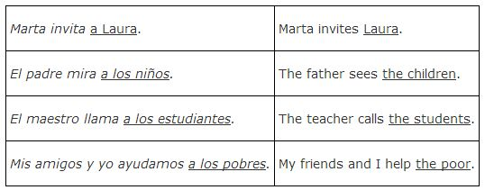

Direct object pronouns
Once you have determined that the noun you want to replace with a pronoun is serving as the direct object of the sentence, you can select the appropriate pronoun from the direct object case of Spanish pronouns. Table 1 lists the Spanish direct object pronouns. To determine which pronoun is appropriate, consider what pronoun you would have used if you were using a subject pronoun, and then select the direct object pronoun from the same “spot” in the table.
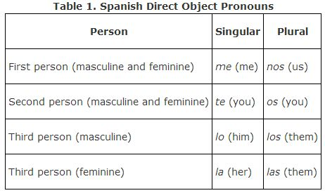

There is no need for a neutral pronoun, like the English word “it,” because all nouns have gender in Spanish. Lo means “him,” but when used to replace masculine nouns that are objects, lo is translated as the English word “it.” The direct object pronoun la means “her,” and also means “it” when replacing a feminine noun that is an object. Just remember that lo, la, los, and las refer to both people and things.
Lo and la are also the direct object pronouns for usted. So you must consider the gender of the “you” that you are replacing with a pronoun. Los and las are the direct object pronouns for ustedes, too, and will reflect the gender of the group of people that “you (plural)” refers to.
It is especially confusing when the direct object pronouns la, los, and las look exactly like the definite article la, los, and las. Just remember when one of these words isn't followed by a noun, it is probably replacing one rather than serving as an article.

Direct object pronoun placement
In English, a direct object always follows the verb. It does not matter whether the object has been turned into a pronoun or not. In Spanish, a direct object follows a conjugated form of a verb unless you turn it into a pronoun. When you change a direct object to a pronoun, the direct object pronoun must be moved in front of the conjugated form of the verb. If the sentence is negative, the no or other negative word will precede the direct object pronoun. Watch what happens in the following pairs of examples. The direct object is underlined in each sentence, but in the second sentence it has been changed to a direct object pronoun and moved to directly in front of the verb.

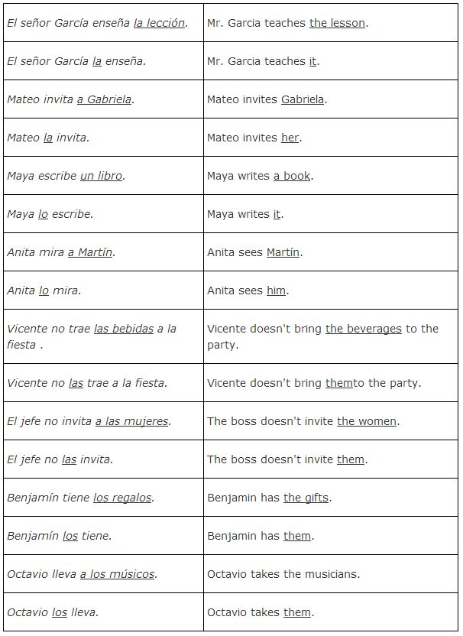
When there are two verbs in the sentence, the first one is conjugated and the second one is used in its infinitive form. In such sentences, the object pronouns can be placed in front of the conjugated verb or can be attached to the end of the infinitive.

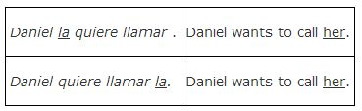
When a sentence is in the present progressive tense, there will be a conjugated form of estar and the present participle form of the verb. Object pronouns may be placed in front of the conjugated form of estar or attached to the end of the verb in the present participle form (ending in – iendo or – ando). This will change the natural stress, so you must add an accent mark to the vowel preceding – ndo when you attach one or two object pronouns. Of course, you can always choose to place the object pronouns in front of the conjugated form of estar and avoid using a written accent mark. Both ways of expressing the progressive are acceptable in Spanish; it does not change the meaning.

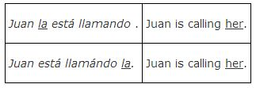

There are specific verbs that require a direct object. These verbs, called transitive verbs, sound incomplete if you try to use them without a direct object. If you say “he brings,” it is technically a sentence but sounds incomplete because the transitive verb “brings” requires a direct object. You can't help but think, “he brings what?” Here are transitive verbs that are commonly used when practicing using direct objects:
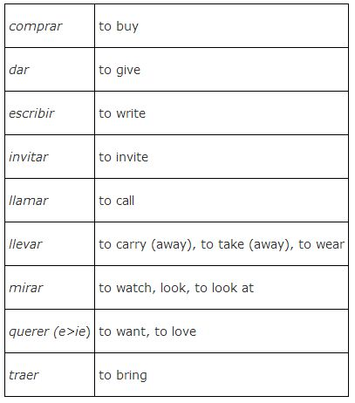

When a sentence has two verbs, the first verb is conjugated and the second verb remains in the infinitive form.
poder
to be able
pagar
to pay
Puedo pagar diez pesos.
I am able to pay 10 pesos.
preferir
to prefer
hablar
to speak
Elena prefiere hablar español.
Elena prefers to speak Spanish.
In sentences with two verbs, there are two options regarding the placement of the direct object pronoun.
- Place it immediately before the conjugated verb.
- Attach it directly to the infinitive.
Here are examples of the direct object pronoun placed before the conjugated verb:
Lo quiero ver.
I want to see it.
Lo debemos comprar.
We should buy it.
María nos debe visitar.
Mary should visit us.
Juan lo necesita lavar.
John needs to wash it.
Here are examples of the direct object pronoun attached directly to the infinitive:
Quiero verlo.
I want to see it.
Debemos comprarlo.
We should buy it.
María debe visitarnos.
Mary should visit us.
Juan necesita lavarlo.
John needs to wash it.
Here are the two methods side by side. Neither method is “better” than the other.
Lo quiero ver.
Quiero verlo.
I want to see it.
Lo debemos comprar.
Debemos comprarlo.
We should buy it.
María nos debe visitar.
María debe visitarnos.
Mary should visit us.
Juan lo necesita lavar.
Juan necesita lavarlo.
John needs to wash it.
These same rules apply for questions and negative statements.
¿Lo debemos comprar?
¿Debemos comprarlo?
Should we buy it?
Juan no lo necesita lavar.
Juan no necesita lavarlo.
John doesn’t need to wash it.

Direct Object Pronoun Placement
Quick Answer
Direct object pronouns don't always go in the same place in a sentence. Their placement depends on things like the mood of the sentence (such as indicative or imperative) and whether the sentence is affirmative or negative.

Indicative Sentences
The indicative is one of three moods in Spanish. It's typically used for making factual statements or describing obvious qualities of a person or situation.

Simple Verbs and Perfect Verbs
In indicative sentences with one simple verb, the direct object pronoun comes before the verb.
Yo la veo.
I see her.

Carmen no lo lee.
Carmen doesn't read it.

Manuel la tiene.
Manuel has it.

María no los tiene.
Maria doesn't have them.

Mi hermano las compra.
My brother buys them.

Direct object pronouns also come before the conjugated verb in sentences that use perfect tenses.
No la he visto.
I haven't seen her.

Los he comprado.
I've bought them.

Infinitives and Present Participles
In indicative sentences that use infinitives or present participles, you can either attach the direct object pronoun to the end of the verb or put it before the first conjugated verb. Check out these examples.
Yo la estoy limpiando.
I'm cleaning it.

Yo estoy limpiándola.
I'm cleaning it.

Lo voy a comprar.
I'm going to buy it.

Voy a comprarlo.
I'm going to buy it.

Note the accent on limpiándola. This is used to preserve the stress on the correct syllable.

Imperative Sentences
The imperative mood is used for giving commands in Spanish. With sentences in the imperative, the placement of direct object pronouns depends on whether the command is affirmative or negative.
- Direct object pronouns are always attached to the end of affirmative commands.
- Direct object pronouns always go between the negative word (no , nunca , etc.) and the verb in negative commands.
Check out these examples.

Affirmative Commands
Léalo.
Read it.

Sácala.
Take it out.

Negative Commands
No lo leas.
Don't read it.

Nunca la saques.
Never take it out.

Note the addition of the accent to the affirmative command forms. You can find more about adding accents when using direct object pronouns here!

Given a noun, choose the correct object pronoun that would replace it.
los momentos
- 1
lo
- 2
te
- 3
las
- 4
los
- 5
me
las flores
- 1
los
- 2
lo
- 3
la
- 4
te
- 5
las
El río
- 1
los
- 2
las
- 3
os
- 4
la
- 5
lo
STREAK x3

Las jarras
- 1
la
- 2
lo
- 3
las
STREAK x4
- 4
te
- 5
los
Usted
- 1
lo
STREAK x5
- 2
me
- 3
la
- 4
te
- 5
nos
los papeles
- 1
me
- 2
las
- 3
la
- 4
los
STREAK x6
- 5
lo
El pastel
- 1
las
- 2
me
- 3
lo
STREAK x7
- 4
los
- 5
la

la sopa
- 1
ella
- 2
lo
- 3
la
STREAK x8
- 4
él
- 5
me
Yo
- 1
la
- 2
nos
- 3
me
STREAK x9
- 4
te
- 5
lo
Las sillas
- 1
te
- 2
las
STREAK x10
- 3
lo
- 4
los
- 5
la
El novio
- 1
la
- 2
lo
STREAK x11
- 3
los
- 4
las
- 5
te
el televisor
- 1
los
- 2
lo
STREAK x12
- 3
te
- 4
la
- 5
las
nosotros
- 1
los
- 2
las
- 3
os
- 4
me
- 5
nos
STREAK x13

la barca
- 1
los
- 2
la
STREAK x14
- 3
os
- 4
las
- 5
lo
las escaleras
- 1
lo
- 2
os
- 3
la
- 4
las
STREAK x15
- 5
los
el suéter
- 1
las
- 2
los
- 3
la
- 4
me
- 5
lo
STREAK x16
la ventana
- 1
nos
- 2
la
STREAK x17
- 3
las
- 4
los
- 5
lo
tú
- 1
me
- 2
lo
- 3
os
- 4
la
- 5
te
STREAK x18

La pelota
- 1
lo
- 2
él
- 3
ella
- 4
me
- 5
la
STREAK x19
el reloj
- 1
ella
- 2
él
- 3
las
- 4
lo
STREAK x20
- 5
la
las blusas
- 1
te
- 2
lo
- 3
los
- 4
la
- 5
las
STREAK x21
La fotografía
- 1
lo
- 2
los
- 3
las
- 4
la
STREAK x22
- 5
me
el tren
- 1
las
- 2
lo
STREAK x23
- 3
la
- 4
los
- 5
me

Ellas
- 1
la
- 2
las
STREAK x24
- 3
te
- 4
los
- 5
lo
el ciervo
- 1
la
- 2
los
- 3
lo
STREAK x25
- 4
os
- 5
las
ellos
- 1
los
STREAK x26
- 2
la
- 3
os
- 4
lo
- 5
las
el abuelo
- 1
os
- 2
los
- 3
la
- 4
lo
STREAK x27
- 5
las
vosotros/as (Spain)
- 1
la
- 2
os
STREAK x28
- 3
las
- 4
te
- 5
los
las mujeres
- 1
los
- 2
ellas
- 3
las
STREAK x29
- 4
ellos
- 5
te
la mano
- 1
lo
- 2
me
- 3
la
STREAK x30
- 4
las
- 5
los
Ustedes
- 1
nos
- 2
los
STREAK x31
- 3
lo
- 4
os
- 5
las

el tenedor
- 1
nos
- 2
las
- 3
los
- 4
la
- 5
lo
STREAK x32
el postre
- 1
ella
- 2
los
- 3
lo
STREAK x33
- 4
la
- 5
él
el sillón
- 1
lo
STREAK x34
- 2
me
- 3
los
- 4
las
- 5
la
la escuela
- 1
los
- 2
lo
- 3
la
STREAK x35
- 4
nos
- 5
las
los perros
- 1
las
- 2
me
- 3
los
STREAK x36
- 4
lo
- 5
la
el queso
- 1
las
- 2
los
- 3
lo
STREAK x37
- 4
me
- 5
la
Los problemas
- 1
te
- 2
las
- 3
la
- 4
los
STREAK x38
- 5
lo
el agua
1.1 lo
- 2
los
- 3
las
- 4
me
- 5
la
la cabeza
- 1
las
- 2
os
- 3
lo
- 4
la
- 5
los

Choose the correct pronoun.
  - They want the book.
Lo quieren.
  - I know them. (Juan and Maria)
Los conozco.
  - Juan knows me.
Me conoce.
  - You love me.
Me amas.
  - You-all (formal) drink milk.
La beben.
  - He buys the magazines.
Las compra.
  - They see Maria.
La ven.
  - I have the pen. (la pluma)
La tengo.
  - You-all (familiar) want the house.
La queréis.
  - I love you.
Te amo.

Translate the following sentences by writing the appropriate form of the verb.
  - You-all (formal) understand the lesson. (comprender)
La comprenden.
  - She watches televisión. (mirar)
La mira .
  - You (familiar) understand the lesson. (comprender)
La comprendes .
  - I love her. (amar)
La amo .
  - She believes it. (creer)
Lo cree .

Answer the following questions. The answer will substitute a pronoun for the direct object noun. JESSICA, BOTH SENTENCES SHOULD BE PROVIDED FOR EACH NUMBER, A BLANK SHOULD BE IN PLACE OF THE BOLDED ANSWER IN THE SECOND SENTENCE. STUDENTS WILL FILL IN THE BLANK
  - ¿Dónde compra Pablo los libros?
Los compra en la librería.
  - ¿Conoces la capital de España?
Sí, la conozco.
  - ¿Miras las telenovelas?
Sí, las miro.
  - ¿Dónde estudia Bill el español?
Lo estudia en Guatemala.
  - ¿Comprenden ustedes esta lección?
Sí, la comprendemos.

- Juan prefiere hablar el español.
Juan prefiere hablarlo.
- Juan prefiere hablar el español.
Juan lo prefiere hablar.
- Ud. debe comprar la pluma.
Usted la debe comprar.
- Usted debe comprar la pluma.
Usted debe comprarla.
- Preferimos comer los mariscos.
Los preferimos comer.
- Preferimos comer los mariscos.
Preferimos comerlos .
- Quiero ver el menú.
Lo quiero ver.
- Quiero ver el menú.
Quiero verlo .
- Quieres comprar la casa.
La quieres comprar.
- Quieres comprar la casa.
Quieres comprarla .
- María debe visitar a nosotros.
María nos debe visitar.
- María debe visitar a nosotros.
María debe visitarnos .
- Quiero invitar a María.
La quiero invitar.
- Quiero invitar a María.
Quiero invitarla .
- Tenemos que comprar el coche.
Lo tenemos que comprar.
- Tenemos que comprar el coche.
Tenemos que comprarlo .
- La chica necesita estudiar la lección.
La chica la necesita estudiar.
- La chica necesita estudiar la lección.
La chica necesita estudiarla .
- ¿Quiero invitar a Carmen?
¿La quiero invitar?
- ¿Quiero invitar a Carmen?
¿Quiero invitarla .

Choose the sentence below that best demonstrates the appropriate use of the direct object pronoun.

Yo llevo los libros a clase.
- Yo los llevo a clase.
- Yo las llevo a clase.
- Yo lo llevo a clase.

Ella invita a los chicos.
- Ella la invita.
- Ella las invita.
- Ella los invita.
Mi madre llama a mi padre durante el día.
- Mi madre lo llama durante el día.
- Mi madre las llama durante el día.
- Mi madre los llama durante el día.
Amelia compra las salchichas en el supermercado.
- Amelia los compra en el supermercado.
- Amelia la compra en el supermercado.
- Amelia las compra en el supermercado.
La señora Lema enseña los verbos a los alumnos.
- La señora Lema las enseña a los alumnos.
- La señora Lema los enseña a los alumnos.
- La señora Lema lo enseña a los alumnos.

Este chico mira la tele todas las noches.
- Este chico lo mira todas las noches.
- Este chico la mira todas las noches.
- Este chico las mira todas las noches.
Mario trae las bebidas a la fiesta.
- Mario las trae a la fiesta.
- Mario lo trae a la fiesta.
- Mario la trae a la fiesta.
Elena y Ana tienen el dinero para el helado.
- Elena y Ana los tienen para el helado.
- Elena y Ana la tienen para el helado.
- Elena y Ana lo tienen para el helado.

Rosalita no vende las plantas en su tienda.
- Rosalita no las vende en su tienda.
- Rosalita no la vende en su tienda.
- Rosalita no los vende en su tienda.

Mariana ayuda los animales los fines de semana.
- Mariana la ayuda los fines de semana.
- Mariana lo ayuda los fines de semana.
- Mariana los ayuda los fines de semana.
Answer the following question replacing the direct object in the sentence with the appropriate direct object pronoun. Remember to change the form of the verb when necessary.

Modelo: ¿Compraste el vestido?
Sí, lo compré.

- ¿Tienes el libro? Sí, lo tengo.
- ¿Buscas los papeles? Si, los busco.
- ¿Encuentras los libros? Sí, los encuentro.
- ¿Tiene Alejandro la tarea? Sí la tiene.
- ¿Buscas las bananas? Sí las busco.
- ¿Haces la tarea? Sí, la hago.
- ¿Miras las películas en el cine? Sí, las miro.
- ¿Pones tus libros en la mochila? Sí los pongo.
- ¿Conoces a Miguel? Sí ,lo conozco.
- ¿Preparas las comidas en tu casa? Sí, las preparo.

Answer the following question based on what you have learned about direct objects, direct object pronouns, and their placement.
- A direct object is the person or thing that DOES the action. True or False
- What someone does is the verb in the sentence. True or False
- The subject is always the person in the sentence. True or False.
- In Spanish if you do something to a PERSON, you must put “a” before that person. True or False

Choose the appropriate answer.

Mario toma el pollo y __________ la bolsa.
lo pone
la pone
las pone

Patricia recoge la carta y __________ .
lo lee
las lee
la lee

Me gustan los pantalones; __________mañana.
las compro
los compro
lo compro

Preparamos las tostadas y __________ en la cocina.
nos comemos
las comemos
los comemos

Rafael lee el periódico y después __________a Silvia.
Lo da
Lo doy
La da
El fotógrafo saca las fotos y __________ al editor.
los enseña
las enseña
la enseña
Replace the direct object in the sentence with the appropriate direct object pronoun and verb when necessary.

1.Bernardo toma la limonada. Bernardo La/la toma.
2.Ramón no hace la tarea. Ramón no La/la hace.
3.Visito a mis abuelos. Los/los visito.
4.Los estudiantes reciben las cartas de la maestra. Los estudiantes Las/las reciben.
5. Carlos cierra la puerta fuertemente. Carlos La/la cierra.
6. Los niños practican los verbos en la clase. Los niños Los/los practican.
7. Marta y yo ponemos los cuadernos en la mesa. Marta y yo Los/los ponemos.
8. David pasa el parque cuando camina a la escuela.
David Lo/lo pasa.
9. ¿Recoges las flores en el parque? ¿Las/las recoges en el parque?
10. ¿Quién cocina el pollo? Mi mama Lo/lo cocina.
11. ¿Tienes la tarea? Sí, ( I have it.) La tengo/la tengo.
12. ¿Esperas el autobus? Sí, (I wait for it.) Lo espero/lo espero.
13. ¿Escuchas la radio? Sí, (I listen to it.) La escucho/ la escucho.
14. ¿Pones tu mochila aquí? Sí, (I put it) aquí. La pongo/la pongo.
15. ¿Cierras la puerta? Sí, (I close it) siempre. La cierro/la cierro.
16. ¿Cierran Uds. las ventanas? Sí, (we close them.) Las cerramos/las cerramos
17. ¿Haces el examen? Sí, (I do it). Lo hago/lo hago
18. ¿Conoces a Pedro? Sí, (I know him.) Lo conozco/lo conozco
19. ¿Das el lápiz a Natalia? Sí, (I give it) a ella. Lo doy/lo doy
20. ¿Ves la lluvia? Sí, (I see it.) La veo/la veo.

Jessica: We want this next activity to be instructor graded, but can it only present 10 of the 40 to students randomly? We don’t want to have to grade 40 per student.

Rewrite the sentence using the appropriate direct object pronoun in complete sentences.

Veo (Usted-feminine)
Necesito lavar (la camisa).
Por favor, sigan (las instrucciones).
Vamos a ver (él).
Tengo que limpiar (la casa).
¿Trajo (el libro)?
Necesito llamar (tú).
Puede levantar (la piedra).
Ven (nosotros).
Están escuchando (música).
Quiero (el coche).
Voy a comer (el pan).
Tengo (ellos).
Leo (la respuesta).
Comieron (el desayuno).
Conozco (el libro).
Ella compró (un equipo de sonido) en la tienda de electrodomésticos.
Siguen pensando (el tema).
Ella ve (me).
Estoy escribiendo (el informe-report).
¿Vas a comer (el jamón)?
¿Puedes hacer (los ejercicios)?
Van a llamar (Pedro y yo).
Adquiero (el coche).
Ando buscando (los papeles).
¿Puedes pintar (la casa)?
Veo (ella).
¿Puedes oír (me) ahora?
Debes enviar (los paquetes).
¿Por qué no puedo ver (la television)?
No tenemos que hacer (la tarea) ahora mismo.
Quiero (este).
Quieres visitor (Elena).
Él quiere ver (tú) mañana.

